15.40: (a)
( c)(e) If the wave traveling in the 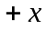 direction is written as 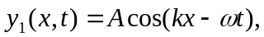then the wave traveling in the (f) The harmonic cannot be determined because the length of the string is not specified.

